Phishing Email Detection Using Machine Learning Models

Ashmita Neupane
Department of Information Assurance
St Cloud State Uniervsity
St Cloud, USA
ashmita.neupane.2@go.stcloudstate.edu
Anjali Suwal
Department of Information Assurance
St Cloud State Uniervsity
St Cloud, USA
asuwal@go.stcloudstate.edu

Abstract—With the rise of large language models (LLMs), phishing attacks have significantly changed as well making them more realistic and harder to detect. With the help of AI cybercriminals can now generate emails that are context-aware, fluent, and highly persuasive, allowing them to bypass traditional detection methods that rely on spelling errors, suspicious links, or known signatures. This study explores practical, data-driven approaches to identifying AI-generated phishing emails using statistical analysis and machine learning techniques.
We evaluated Logistic Regression and Random Forest, on a dataset of 18,650 labeled emails. Two text preprocessing strategies were compared: light cleaning, which retains functional words, and aggressive cleaning, which removes stopwords and punctuation. Our results indicate that ensemble methods, particularly Random Forest with light cleaning, achieved the best performance, with 95.4% accuracy, 94.5% recall, and an F1-score of 0.942. Key indicators such as phrases like “click here,” “http,” and urgent wording remained effective for detection, demonstrating that identifiable patterns persist even in AI-generated messages.
These findings highlight that interpretable machine learning models can provide a strong first line of defense but robust security requires combining text analysis with metadata inspection and continuously updated models. As AI continues to advance, detection strategies must also evolve as well to include behavioral analysis, adversarial resistance, and direct identification of AI-generated content. This work provides a foundation for enterprise systems capable of defending against the next generation of AI-driven phishing threats.

Introduction

Background
Phishing has long history of being one of the most prevalent forms of cybercrime, targeting people rather than exploiting software vulnerabilities. Traditionally, phishing emails were relatively easy to detect, as they often contained spelling mistakes, awkward phrasing, or suspicious links. Rule-based filters, blacklists, and signature-based detection systems were typically effective at blocking these attempts. However, the arrival of large language models (LLMs) has changed everything as these AI models can generate highly fluent, context-aware, and convincing emails, making phishing campaigns harder to detect.
The rise of large language models (LLMs) has significantly intensified phishing threats, and this shift is clearly reflected in recent reports. In 2024, Cofense reported that its Phishing Defense Center detected a new malicious email every 42 seconds, leveraging AI to bypass conventional filters [1]. Zscaler’s ThreatLabz report noted a 60% increase in phishing attacks, driven by AI tactics including polymorphic emails, voice phishing, and deepfake content [2]. SlashNext documented a 341% rise in Business Email Compromise (BEC) attacks following widespread access to AI tools like ChatGPT [3]. Furthermore, VIPRE Security found that 40% of BEC emails analyzed in 2024 exhibited linguistic markers consistent with AI generation [4], and KnowBe4 observed that 82.6% of phishing emails between mid-2024 and early 2025 showed signs of AI influence [5]. Academic studies also demonstrate that LLMs can produce realistic phishing content with minimal human input, lowering the barrier for attackers [6].
Together, these findings indicate that AI has made phishing attacks more sophisticated, scalable, and harder to detect using traditional methods.
B. Motivation
With the rise of AI-generated phishing emails, developing detection strategies has become increasingly important. Unlike traditional phishing, these AI-crafted messages can be highly personalized, contextually accurate, and generated at large scale. Attackers can mimic the style and tone of legitimate communications, making even careful users more likely to be deceived [1][2], and recent analyses show that AI significantly boosts attackers ability to craft believable messages [15][16].
Most existing anti-phishing tools are designed for human-written emails which rely on clues like spelling mistakes, awkward phrasing, or inconsistent formatting. However, emails created by large language models are fluent, coherent, and context-aware, which allows them to bypass these traditional defenses [5][6]. This gap leaves organizations exposed to risks such as credential theft, financial fraud, and business email compromises.
To overcome this challenge, detection methods need to be AI-aware. Effective approaches should combine analysis of both linguistic patterns and behavioral signals for the correct identification of AI-generated phishing with low false positives. Such strategies can provide organizations with stronger, more reliable protection against the evolving threats posed by AI-driven attacks [3][4].
C. Problem Definition
The focus of this study is the detection of phishing emails generated by large language models (LLMs). These AI-generated emails are designed to closely mimic legitimate messages, replicating tone, style, formatting, and context-aware content, which makes it hard to differentiate from genuine communications [1][3][6], aligned with recent cybersecurity findings showing LLMs increasing capability in assisting cyberattacks [17].
Traditional phishing detection methods such as rule-based filters, blacklists, or signature-based approaches were effective against human-written emails that often-contained errors, unusual phrasing, or obvious malicious links. However, these methods struggle against AI-generated messages, which are fluent, consistent, and capable of bypassing conventional security measures [2][5].
The challenge, therefore, is to develop detection strategies that can accurately identify AI-generated phishing while minimizing false positives. This requires analyzing both textual and behavioral features to detect subtle patterns and cues that distinguish malicious AI-generated emails from legitimate correspondence, providing organizations with robust defenses against this emerging threat [4][6].

Background and related work
Traditionally, phishing detection has depended on rule-based systems, blacklists, and signature-based tools to identify malicious emails. These methods look for known patterns, suspicious links, or unreliable senders. While they work well against familiar attacks, they often fail when attackers use new techniques or disguise their messages cleverly. With the rise of AI-generated content, phishing attacks are becoming sophisticated, and detection methods need to keep up.

Traditional Phishing Detection Models
In the early days, phishing defenses were mainly static. Blacklists and rule-based filters flagged emails with certain keywords or from known malicious domains, while signature-based antivirus systems looked for predefined patterns [7]. These methods, however, struggle to catch new or unexpected phishing attacks.
To improve detection, researchers began using machine learning models that analyze email features like headers, word patterns, and embedded URLs. Algorithms such as Support Vector Machines (SVM), Random Forests, and Naive Bayes have been moderately successful at identifying phishing emails based on statistical patterns [8][9]. More recently, Natural Language Processing (NLP) has allowed for a deeper understanding of email content, helping to detect more context-aware and sophisticated phishing messages. Still, many traditional approaches rely on obvious surface-level cues that attackers can easily bypass.

Challenges with AI-Generated Phishing
Large language models (LLMs) like ChatGPT and Claude have made phishing attacks more difficult to detect. These models can generate emails that are fluent, grammatically correct, and contextually relevant, making them look very similar to legitimate messages. Unlike older phishing emails, which often had mistakes or odd phrasing, LLM-generated emails appear professional, reducing the effectiveness of traditional filters [10].

Attackers can also customize prompts to create phishing emails that evade detection by rephrasing malicious content or embedding harmful intent in seemingly safe language. Studies show that models trained on older phishing datasets do not perform well against these AI-generated messages, revealing a clear weakness in current detection systems [11]. This highlights the need for smarter, adaptive methods that combine language analysis, behavioral cues, and resilience to adversarial attempts [17].

Data and methods

Dataset
We picked out our dataset from Kaggle named “Phishing_Email.csv” [18]. This dataset contains 18,650 emails, which is a mix of both phishing and safe emails, and each email is labeled as “Phishing Email” or “Safe email”. The dataset was then loaded to R Studio, and then column names were renamed to id, text, and label. The dataset consists of 7,328 phishing emails and 11,322 safe emails. Fig1 shows the dataset distribution in the bar chart with 40% being phishing data and 60% being safe.
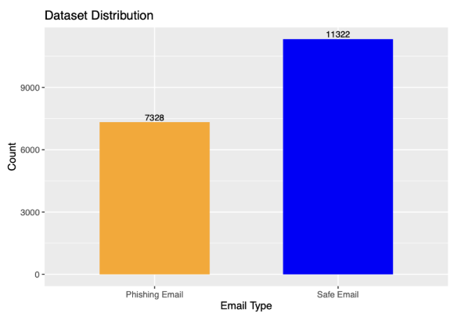
Fig. 1. Dataset distribution

Preprocessing
We explored two levels of text cleaning:

1) Aggressive Cleaning
- Converted all text to lowercase.
- Removed punctuation and numbers.
- Removed common English stopwords (“the”, "and”, “to” etc).
- Removed extra whitespace.

2) Light Cleaning
- Converted all text to lowercase.
- Removed punctuation and numbers.
- Removed extra whitespace.
- Do not remove stopwords.

Since data preprocessing is an important step, we were curious to see how the cleaning process might affect the accuracy rate for the machine learning models, which is why we decided to explore two levels of cleaning process.

For each cleaning type, we built a text corpus using the tm package in R and created a DocumentTermMatrix (DTM) weighted by TF-IDF. DTM represents each email as a row, and each unique word (term) as a column.

For both cleaning levels, we converted the email corpus into a numerical format that could be used for machine learning models. For this step, DocumentTermMatrix() function was used from tm package in R Studio. The values in the matric indicate the frequency of each word in each email. For instance, if the word “click here” appears in the email twice, the value will contain 2 in the corresponding cell. Since the original email contains a very large number of unique words which may only appear once or twice, the matrix can be extremely large and sparse. To avoid this, very sparse terms were removed (using removeSparseTerms with a threshold of 0.97) to keep only relatively frequent words and reduce dimensionality.

Now the DTM is converted into a standard data-frame format using the as.data.frame() function. A single email is represented by each row in the data frame, while a particular word from the corpus is represented by each column. As mentioned before, each word frequency in the email is represented in numbers.

Train-Test Split
The dataset was split into training and testing sets using 80/20 ratio using createDataPartition from the caret package. 80% of the original data was used as training data to build the machine learning models, while 20% testing data was used to evaluate model performance.

Models
We used two machine learning models:

Logistic Regression (LR): Logistic Regression was implemented using the glm function with a binomial family. Since this model uses binary (0, 1) classification, we converted our target variable to 0 and 1, 0 being legitimate emails whereas 1 being phishing. The maximum number of iterations was left to default, which was 100. We observed warnings during training that some fitted probabilities were numerically near to 0 or 1, which is a typical behavior for Logistic Regression when the data is strongly separable.

Random Forest (RF): The randomForest package was used to implement the Random Forest classifier. Random Forest model requires a target variable to be a factor so that was implemented before we trained the model. The model was then trained using the default hyperparameters, or the number of trees for classification. We calculated feature importance values by using Mean Decrease Gini metric to determine which phrases were most important in differentiating phishing emails from safe emails. This is an important visualization to see what model relies on when detecting phishing email contents.

Evaluation Metrics
We used the following metrics to compare both models with two cleaning levels:
- Accuracy: Indicates what percentage of the model predictions were accurate [12]. Even though it tells us the overall fractions of correctly classified emails, it could be misleading if you have an imbalanced dataset.

- Precision (Positive Predictive Value): Calculates the percentage of the model’s positive predictions that come true [12]. In other words, among emails predicted as phishing, how many are actually phishing.

- Recall (Sensitivity): Measures the proportion of real positive cases that the model accurately identified [12]. Among all actual phishing emails, how many are correctly detected.

- F1-Score: Harmonic mean of precision and recall. In other words, it is a balance between precision and recall [12].

- ROC-AUC: It stands for Receiver Operating Characteristic Area Under the curve. It captures how well the model distinguishes between true positive and false positive. The higher the curve, the better model is at making the right predictions [13].

- Confusion Matrix: Compares predicted values with the actual values. It calculates four different values, true positives, false positives, true negatives, and false negatives [14].

Results

Overall Performance
Table 1 summarizes the performance of both models and two preprocessing levels for each model we got from R.

TABLE 1 – Performance Comparison of Logistic Regression and Random Forest
Model | Cleaning | Accuracy | Precision | Recall | F1-Score | ROC-AUC
Logistic Regression | Light | 0.943 | 0.912 | 0.947 | 0.929 | 0.983
Random Forest | Light | 0.954 | 0.939 | 0.945 | 0.942 | 0.953
Logistic Regression | Aggressive | 0.936 | 0.899 | 0.943 | 0.920 | 0.978
Random Forest | Aggressive | 0.953 | 0.926 | 0.955 | 0.941 | 0.953

Under light cleaning, Random Forest achieves the highest accuracy of 95.4% and F1-score of 0.942, outperforming Logistic Regression by about 1.1 percentage points in accuracy. ROC-AUC for Logistic Regression is slightly higher (0.983 vs. 0.953), which indicates that Logistic Regression produces strongly separated probability scores even if its classification threshold is not better compared to Random Forest.

Under aggressive cleaning, Random Forest still performs very well (95.3% accuracy, F1 score 0.941), while Logistic Regression accuracy decreases slightly to 93.6%.

Effect of Preprocessing (Light Vs Aggressive)
Fig. 2 shows the bar chart that compares model accuracies for Light vs. Aggressive cleaning.

For Logistic Regression, accuracy decreases from 94.3% (light cleaning) to 93.6% (aggressive cleaning). However, Random Forest ‘s accuracy did not fluctuate a lot, 95.4% (light cleaning) vs. 95.2% (aggressive cleaning).

This satisfies our curiosity by demonstrating that aggressively cleaning and eliminating stopwords does not enhance the model’s performance, in fact it harms linear models like Logistic regression which depend on lexical context. Because Random Forest is non-linear, and uses ensembles of trees, it seems to be more reliable.

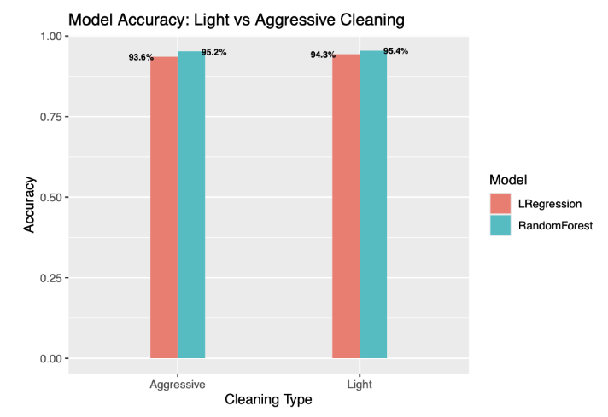
Fig. 2. Compare Model Accuracy: Light vs Aggressive Cleaning

Confusion Matrix
The confusion matrix for Random Forest model for light cleaning setup is shown in Fig. 2.
- True Positive (phishing correctly classified as phishing): 1,385
- False Negative (phishing misclassified as safe): 90
- False Positive (safe misclassified as phishing): 80
- True Negative (safe correctly classified as safe): 2,174

With just 80 false positives and 90 false negatives, the Random Forest model successfully identified 1385 phishing emails and 2174 safe emails. The confusion matrix is an important evaluation metric because it breaks down the numbers for all four values. The false negative is especially important for phishing detection due to security risks.
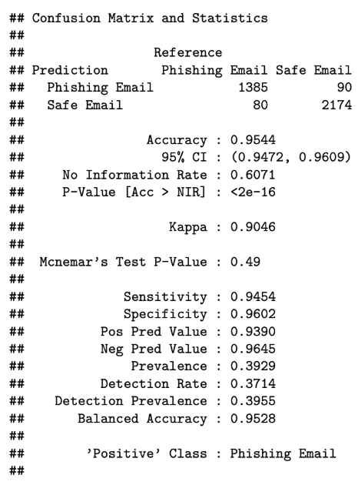
Fig. 3. Confusion Matrix for Random Forest

The confusion matrix for the Logistic Regression model for light cleaning setup is shown in Fig. 4.
- True Positive (phishing correctly classified as phishing): 1,387
- False Negative (phishing misclassified as safe): 78
- False Positive (safe misclassified as phishing): 133
- True Negative (safe correctly classified as safe): 2,131
The Logistic Regression model gave 1387 true positives, 78 false negatives, 133 false positives, and 2131 true negatives. Random Forest achieved 80 false positives whereas Logistic Regression achieved 133. This shows that Random Forest model is more precise than Logistic Regression.

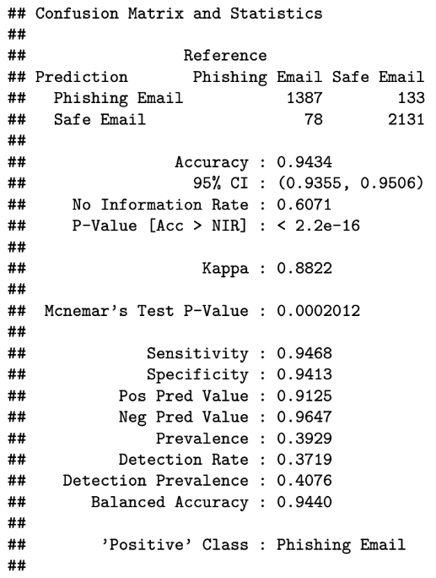
Fig 4. Confusion Matrix for Logistic Regression

ROC-AUC Curves
As shown in Fig. 5, both models operate close to the top-left corner of the ROC space, and as mentioned before, the higher the curve the better model is at making the right predictions. Logistic Regression’s ROC curve slightly dominates Random Forest, with the higher ROC-AUC value (0.983).

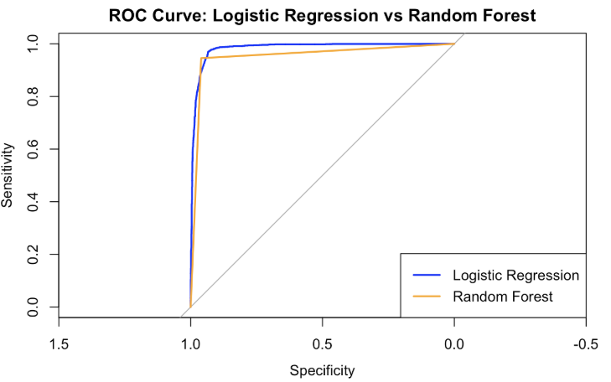
Fig. 5. ROC-AUC Curves for LR and RF

Feature Importance
We examined the Random Forest feature-importance scores and Logistic Regression coefficients to have a better understanding of how each model predicts.
For Logistic Regression, Fig 6, words like “http”, “investment”, “unsubscription”, “reply”, and “you” have the highest positive coefficients, meaning they are strongly associated with phishing. Additionally, some long tokens like httpwwwlinuxiemailmanlistinfoilug also have very high weights because they regularly exist in phishing patterns within the dataset. However, negative coefficients (safe emails) include words like “enron”, “edu”, “linguistic”, and names such as “kaminski” reflecting the legitimate origin of many corporate or academic emails in the dataset.

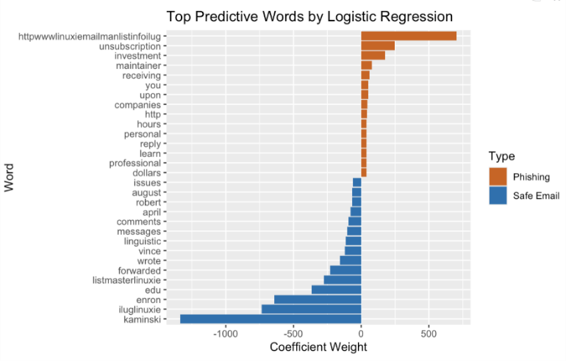

Fig. 6. Top Predictive Words (Logistic Regression)

For Random Forest (Fig. 7), the features with the highest Mean Decrease Gini include words such as “your”, “enron”, “the”, “click”, “here”, “http”, “you”, “our”, “money”, and “university”. Importantly, phrases like “click here” and web tokens like “http” are classic phishing indicators, while “enron” and “university” are associated with legitimate corporate or academic communications.

These results demonstrate that Random Forest model is capturing meaningful patterns that distinguish phishing from safe emails, rather than overfitting the dataset.

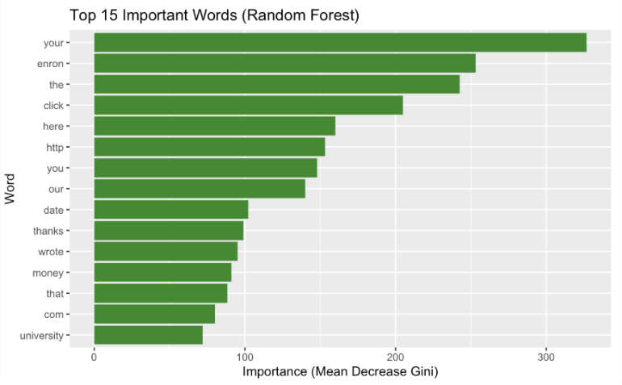
Fig. 7. Top Predictive Words (Random Forest)

Discussion

Strengths and Weaknesses of the Evaluated Models
Our results show that even simple machine-learning models like Logistic Regression and Random Forest with TF-IDF features can achieve over 95% accuracy on a realistic phishing email dataset. Among the two, Random Forest provides the best overall performance in our experiments, while Logistic Regression gave slightly better calibrated probability scores.

The comparison between light and aggressive preprocessing highlights an important insight which is; more data preprocessing does not always give you better results. Removing stopwords can discard useful phishing patterns such as, “you must verify”, “click here to”, etc. For linear models like Logistic Regression that directly relies on TF-IDF weights, this loss of information is more visible than for tree-based models like Random Forest.

Implications for CyberSecuirty
From a cybersecurity standpoint, these models could fit into email gateways as part of a layered defense system. For example, a Random Forest classifier could provide a high-recall phishing score that flags suspicious emails for further analysis. Logistic Regression on the other hand could assist in downstream risk scoring because of its adjusted probabilities.

Our results indicate that models that rely on distributional word statistics and combinations (like TF-IDF) are likely to continue to be helpful in the context of AI-generated phishing. AI-generated emails must nevertheless contain semantics pertaining to requests for credentials, financial, transactions, and urgent activities, even if their grammar is more natural. TF-IDF-based models are able to identify these semantic cues, which frequently take the form of certain word selections or phrases.

Conclusion and open problems
In this project, we built and evaluated machine-learning models for detecting phishing emails using a Kaggle dataset of 18,650 labeled messages. Using TF-IDF features and two levels of text cleaning, we trained Logistic Regression and Random Forest models in R Studio and analyzed their performance.

Random forest with light cleaning achieved the best overall performance, with 95.4% accuracy, 0.939 of precision, 0.945 of recall, and 0.942 of F1-score. Logistic regression also performed well, especially in terms of ROC-AUC (0.983), that indicated strongly separated probability. Aggressive stopword removal did not improve performance, in fact slightly reduced the linear model, meaning that common words contain meaningful patterns for phishing detection.

While our results demonstrate that interpretable machine-learning models are effective and reliable tools for email security, there are still a number of unresolved issues. First, it is unclear how well these machine learning models would perform to more recent LLM-crafted attacks because our dataset did not include AI-generated phishing emails. Second, our models rely on email body text, adding metadata like sender details, embedded URLs, or user behavior signals could greatly improve phishing detection. Lastly, researching more advanced approaches like transformer-based detectors may improve against increasing phishing attacks.

These unresolved issues highlight the need for ongoing innovation in phishing detection research because attackers are increasing and have become more advanced.

References

- Business Wire, “Cofense reveals rapid rise in AI-powered phishing,” Business Wire, May 2025. [Online]. Available: https://www.businesswire.com/news/home/20250514953658/en/Cofense-Reveals-Rapid-Rise-in-AI-Powered-Phishing
- Zscaler, “Zscaler research finds 60% increase in AI-driven phishing attacks,” Zscaler ThreatLabz Report, 2024. [Online]. Available:
https://www.zscaler.com/press/zscaler-research-finds-60-increase-ai-driven-phishing-attacks
- SC Media, “AI-generated emails make up 40% of BEC lures, security firm says,” SC Media, 2024. [Online]. Available:
https://www.scworld.com/news/ai-generated-emails-make-up-40-of-bec-lures-security-firm-says
- PR Newswire, “The new face of fraud: 40% of business email compromise (BEC) emails are AI-generated,” PR Newswire, 2024. [Online]. Available:
https://www.prnewswire.com/news-releases/the-new-face-of-fraud-40-of-business-email-compromise-bec-emails-are-ai-generated-302208820.html
- Security Magazine, “82.6% of all phishing emails utilized AI,” Security Magazine, 2024. [Online]. Available:
https://www.securitymagazine.com/articles/101490-82-of-all-phishing-emails-utilized-ai
- S. Roy, S. Thota, S. Naragam, A. Nilizadeh, et al., “From Chatbots to PhishBots? – Generating phishing scams using ChatGPT, Bard, and Claude,” arXiv preprint arXiv:2310.19181, 2023. [Online]. Available:
https://arxiv.org/abs/2310.19181
- N. Abdelhamid, A. Ayesh, and F. Thabtah, “Phishing detection: A recent intelligent machine learning comparison based on models content and features,” in Proc. IEEE Int. Conf. Intelligence and Security Informatics (ISI), 2014, pp. 72–77. doi: 10.1109/ISI.2014.6958450{[
- A. Bergholz, J. De Beer, S. Glahn, M. F. Moens, J. Piskorski, and D. Stolz, “New filtering approaches for phishing email,” J. Comput. Secur., vol. 18, no. 1, pp. 7–35, 2010. doi: 10.3233/JCS-2009-0371.
- R. Basnet, A. H. Sung, and Q. Liu, “Learning to detect phishing URLs,” Int. J. Res. Comput. Sci., vol. 2, no. 1, pp. 1–12, 2012. doi: 10.5121/ijrcs.2012.2101.
- Y. Shen, C. Zhang, and Y. Liu, “Adversarial robustness of phishing detectors against large language model–generated emails,” in Proc. ACM Workshop on Artificial Intelligence and Security, 2023, pp. 45–54. doi: 10.1145/3603269.3604832.
- L. Zhang, A. Kumar, and X. Li, “Prompt-engineered phishing: Evaluating the threat of LLM-generated social engineering,” IEEE Trans. Inf. Forensics Secur., vol. 19, no. 4, pp. 1123–1135, 2024. doi: 10.1109/TIFS.2024.3298765.
- GeeksforGeeks, “Metrics for machine learning models.” [Online]. Available:
https://www.geeksforgeeks.org/machine-learning/metrics-for-machine-learning-model/
- GeeksforGeeks, “AUC–ROC curve in machine learning.” [Online]. Available:
https://www.geeksforgeeks.org/machine-learning/auc-roc-curve/
- IBM, “Confusion matrix explained.” [Online]. Available:
https://www.ibm.com/think/topics/confusion-matrix
- I. Rehman, “The Capabilities of Large Language Models in Executing/Preventing Cyber Attacks,” Patchstack, 10 May 2024.
- “How AI Is Changing Phishing Attacks,” LazyAdmin, [Online]. Available:https://lazyadmin.nl/it/how-ai-is-changing-phishing-attacks/. LazyAdmin
- C. Sasirekha, R. Nandhini, N. L. Karthiga Mai, R. S. Bhuvaneshwari, and V. S. Chandra, “Email Phishing Detection Using Machine Learning,” International Journal of Engineering Research & Technology (IJERT), vol. 11, no. 03, 2023.
- “Phishing Email Detection,” www.kaggle.com. https://www.kaggle.com/datasets/subhajournal/phishingemails/data ‌

